Linux Commands

- whoami :In Linux to know what we are at the current position we use a command called whoami.
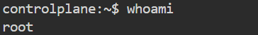
- Touch: We use “touch” command to generate files in a
directory.
- Ls: The “ls” command shows the existing files in the
directory.
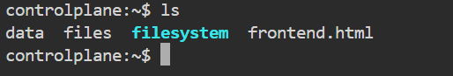
- Cat: The cat command is used to display, combine, or create text files by printing their contents to standard output.
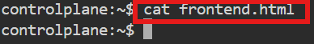
- Vi: vi in Linux is a powerful text editor used to create, view, and edit files directly from the terminal.
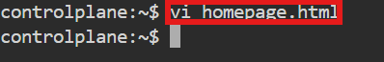
Now paste the code inside the editor and then to exit press
“esc” and type “:wq”

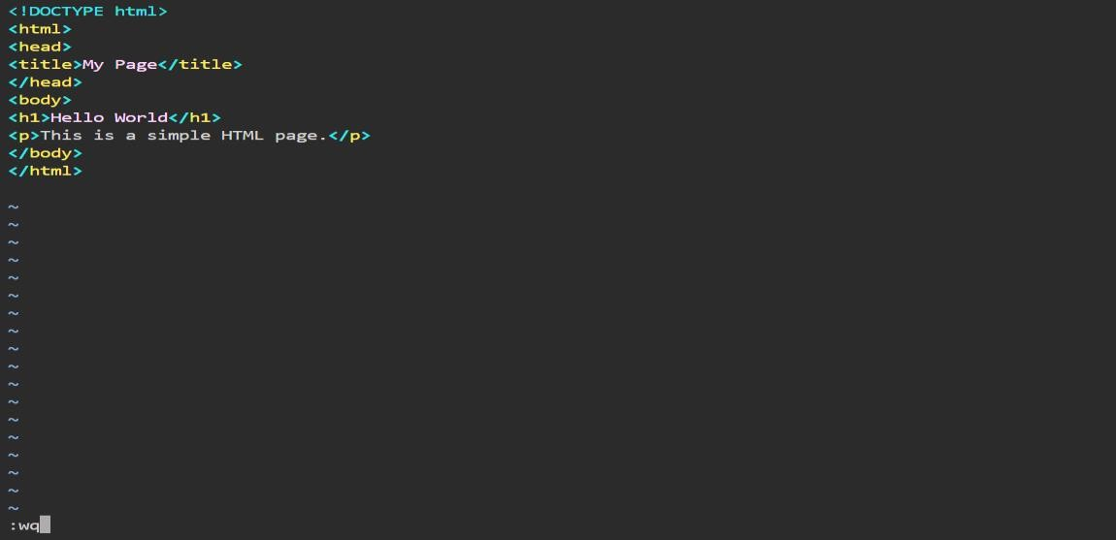
Use “cat homepage.html” to display the code.
- Mkdir: mkdir is a Linux command used to create one or more new directories (folders).
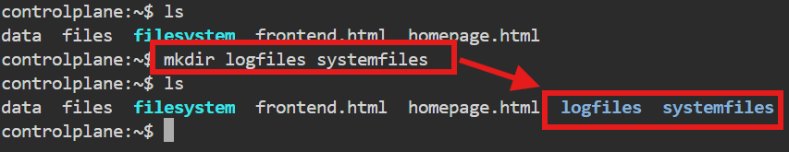
- Cd: cd is a Linux command used to change the current working directory.
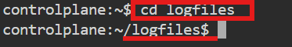
- Rm: To remove a file from the directory we use “rm”
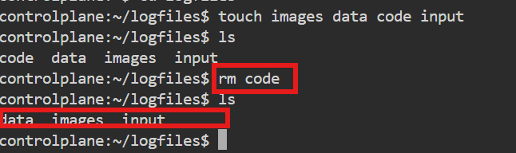

- Rmdir: to remove directory we use “rmdir”

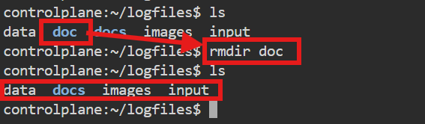
- Rm –rf: To remove the directory which exists files inside that we use this command.
Better not to use in real time; it causes complete deletion and loss of files.
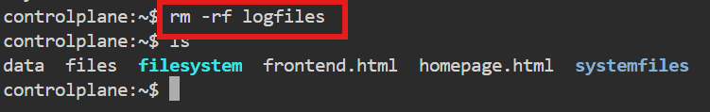

- Cd .. : To exit from the file directory path in Linux.
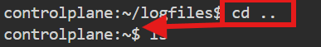
- Cd ../.. : To exit the multiple files in a directory.
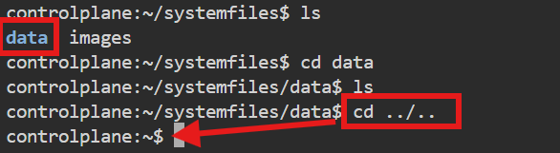

- Copy: The cp command is used in Linux to copy files or directories from one location to another.

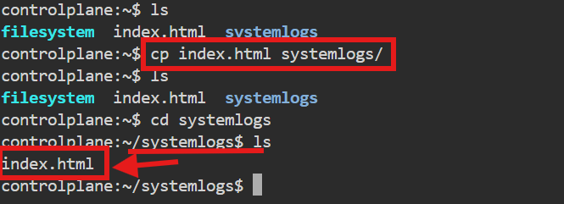
- Move: The mv command is used in Linux to move or rename files and directories.
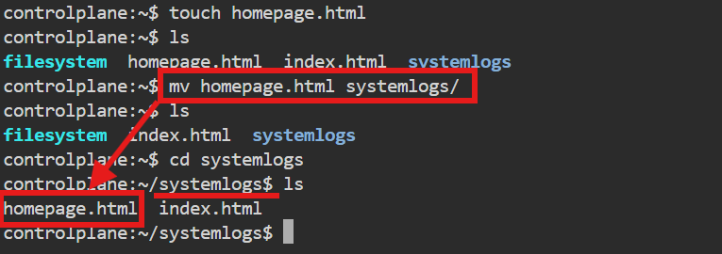
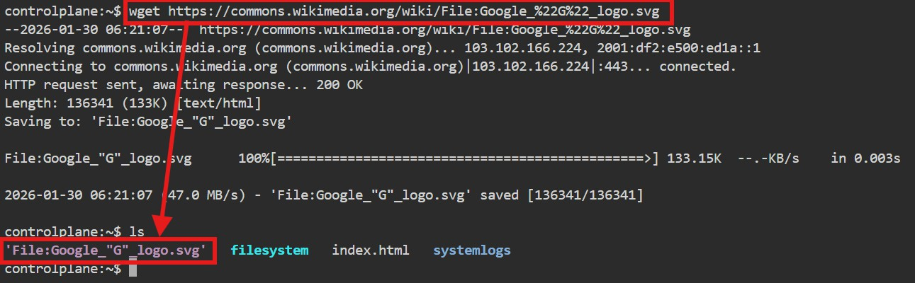
- Wget: It is a Linux command used to download files from the internet using a URL.

- Ping: The ping command in Linux is used to check the network connectivity between your computer and another device.

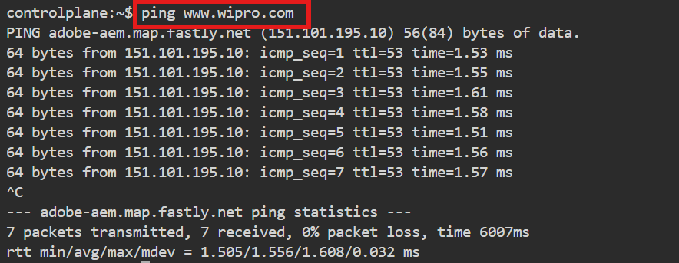
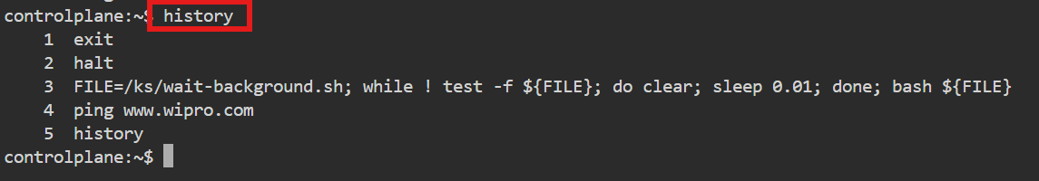
- History: This command gives about the entire number of commands used until this command.

These are some of the commands in Linux

